What can I expect to get  What you should know.  Each Animal is different, some yield better than others.  If you buy a 1200 lb cow you will not get 1200 lbs of meat  Live weight to carcass weight is about 63% and carcass weight to finish meat you can expect 50-60%. |  |  | 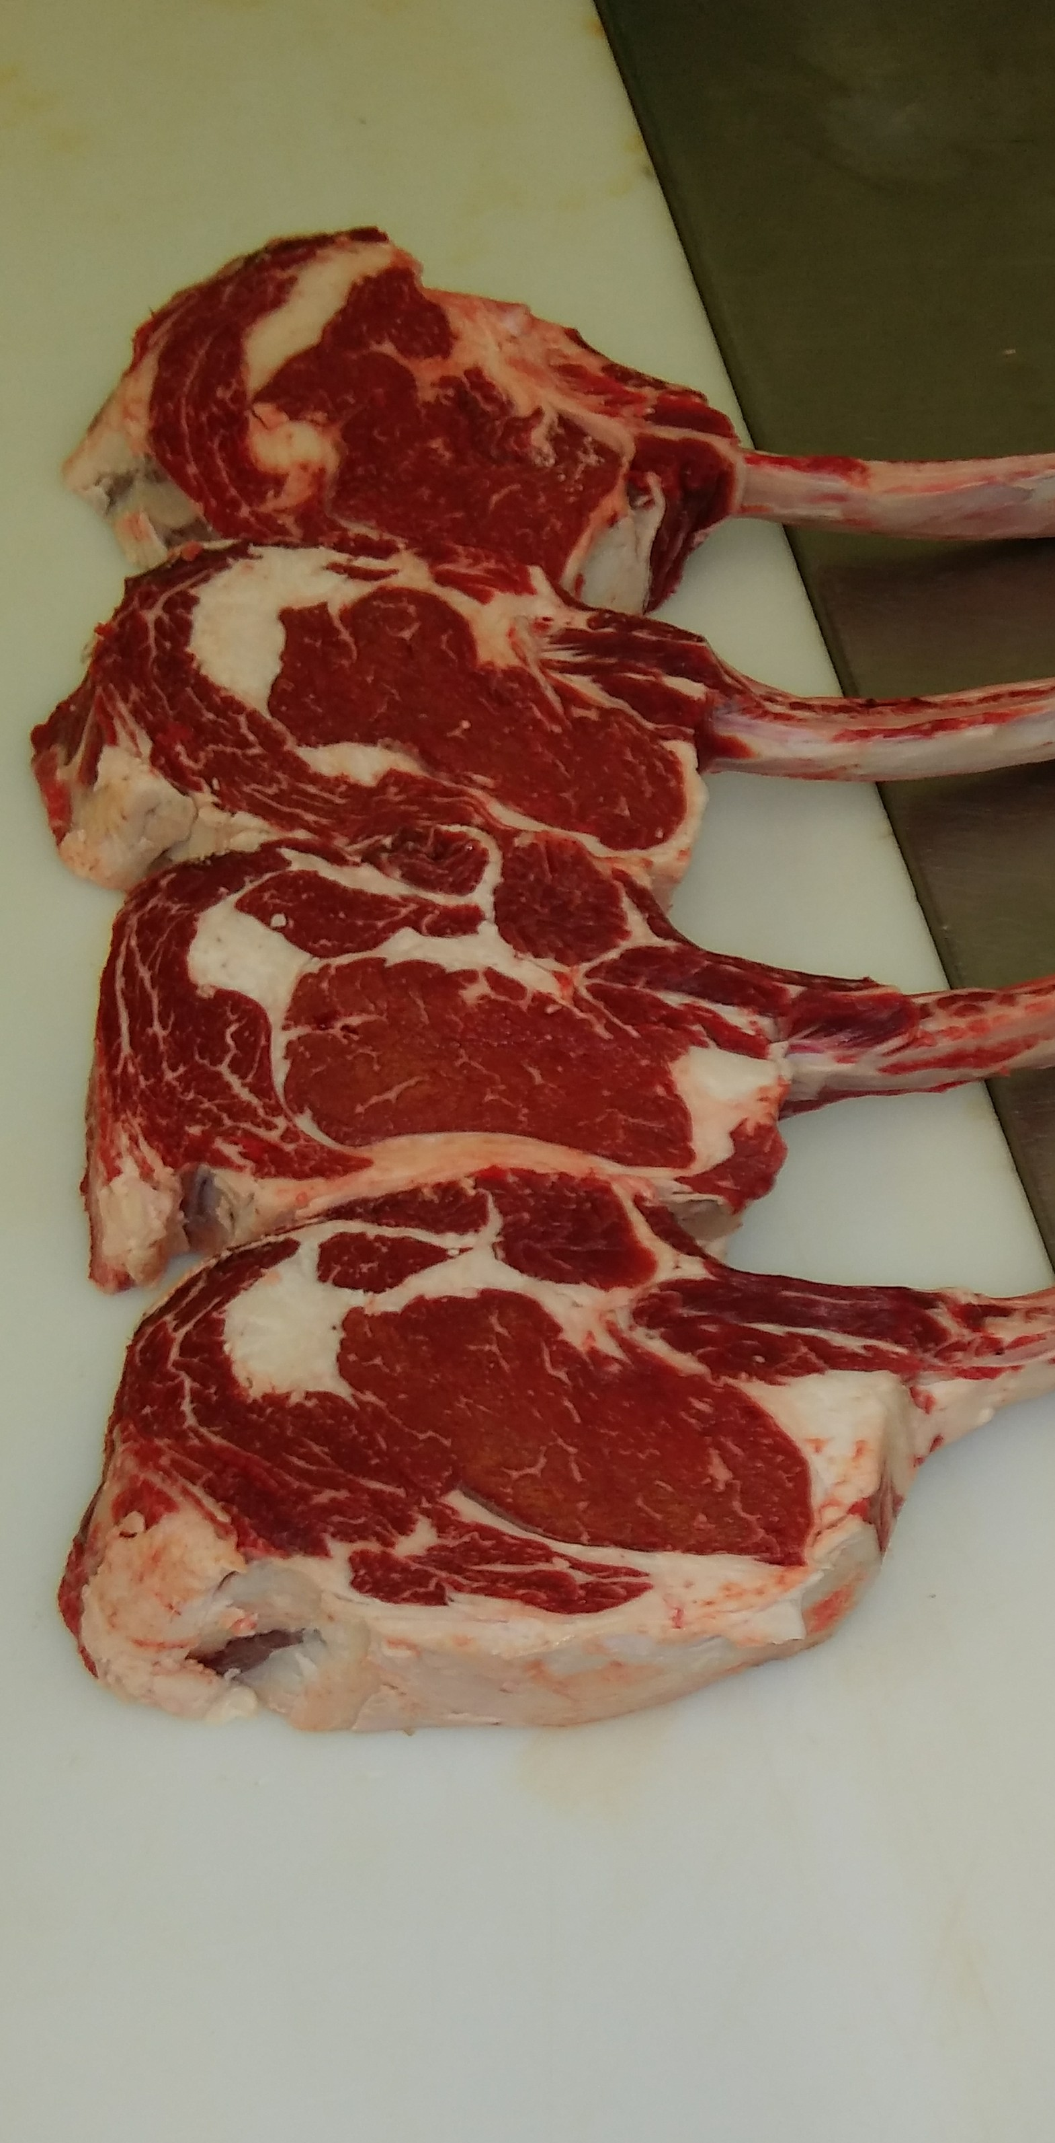 |  |  | Winthrop Locker  - Est. 2008. Here to MEAT all your needs.

Whole Hog  Purchasing From Winthrop Locker  Total cost for purchase and processing together can be in the range of $550-$650  There is a large range in price due to several things; how big the pig is and if you get additional specialty products made from your hog.  Meat from a typical whole hog consists of approximately (note: this is based off average of what people do. Your order will be different based on what you choose to do.)  - 20-25 1’’ thick Pork Chops  - 2 Large shoulder (10-12 lbs. Each)  - Usually cut down to smaller roast and steaks  - 2 Slabs of bacon (sliced & packed for you 12-20 pkgs.)  - 2 large hams (15-18 lbs. each)  - Most commonly is smoked &cured.  - Usually cut down smaller roast or steaks.  - Optional cut could include.  - Spare ribs  - Hocks  - Fresh or smoked.  - 20-30 lbs. of Trim Meat to make into sausage  - Example: And there are more too.  - Ground pork  - Ground sausage  - Breakfast links  - Brats (we have many types of brats) |  |  | Whole Beef  Purchasing From Winthrop Locker  Total cost for purchase and processing together can be in the range of $2,600.00 to $2,800.00.  There is a large range in price due to several things; how big the beef is and if you get additional specialty products made from your beef.  Average Yields for beef (note: this is based off average of what people do. Your order will be different based on what you choose to do.)  - 32 various Beef roast (chuck, arm, rump) 3lbs average.  - 24-26 1’’ thick Ribeye steaks  - 28-30 1’’ thick T-bone steaks  - 14-18 1’’ thick Sirloin steaks  - 8 1’’ thick Sirloin tip steaks  - 14-18 ¾’’ thick Round steaks (can be cut in to minute steaks or stew meat, or made in to Jerky.)  - 280-340 lbs. of Ground beef (can be made in to patties.)  - Various optional cuts like beef ribs, brisket, etc.  On Average total cost per lbs. of meat it will cost you $4.94. This is total cost lbs. of meat in your freezer. So your steaks will cost $4.94 /lbs., your roast $4.94/lbs., your ground beef $4.94.  When I pick up my meat.  When picking up we will have your meat all in brown paper bags or boxes.  You will need to pay the processing bill, cash, check, credit. 4% added for ALL card transactions.  $30 charge for all checks returnd. |  |  | When I bring my animal in to the locker  You Can bring them in before 5pm the day before or have them here at 7:30 am-8:30 am the day of.  Please have all names and contact info for the people receiving meat.  Call in cut orders to the locker on hogs the same day. Beef orders call in sometime that week.  After the order is complete someone will call you and you will need to have the meat picked up within 10 days. If not picked up within 10 day $8.00/month storage will be added to your bill.  Contact Us  Winthrop Locker  835 220th St West  Winthrop, IA 50682  319-935-3886  winthroplocker@hotmail.com  Visit us on the Web:  winthroplocker.com

